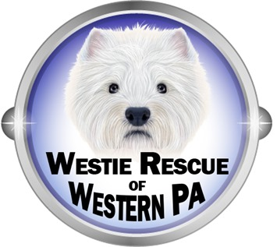

**Foster Contract Form**

As a Foster Care Volunteer for Westie Rescue of Western PA, I agree to comply with the following:

* I understand that although the foster care Westie is in my care, it will remain the property of WR of WPA. I agree to return it to the coordinator on the date specified.
* I will not sell, give away, adopt out or otherwise dispose of any foster Westie in my care.
* I agree to provide regular food, water, exercise, shelter, socialization, grooming (bathing and brushing), and any other requirements arising from the care of a foster Westie.
* I will strictly follow instructions given me by the Rescue Coordinator and veterinarian regarding the care of my foster Westie.
* I understand that any medical costs incurred by my personal pet’s exposure to a foster Westie will not be reimbursed to me. I will take the necessary precautions to protect my personal pets and foster Westie.
* I agree to report any changes in a foster Westie’s health or behavior in a timely manner to the Rescue Coordinator.
* I agree to report the death of any foster Westie to the Coordinator.

Signature ____________________________________ Date __________________